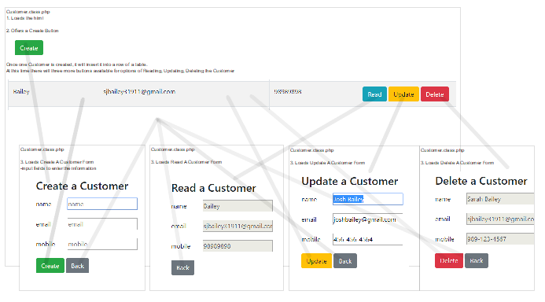

This diagram shows the relation between the functions in the crud_oo_complete file.

First the html is read in the customer.class.php. This will load the header and start the table where the customer information is stored.

The user will first click the “Create” button. At this time, it will call the Create A Customer form. Here is where the user will fill in the customer information ie. name, email and mobile. The user will then either click the create button, this will then call the create_record() and insert_db_record (). At this step the information is checked to make sure it is valid by calling the fieldsAllValid () function, otherwise it will not be submitted into the table/database.

Once this happens, the customer information will be then added to the customer table. Once a customer is place into the database, there will be options to read, update, or delete the file. If the read button is selected the read_record($id) and select_db_record($id) functions will be called, for the specific customer. In the Read A Customer form, there is only a back button. This form will not allow any changes or deletion of the customer file. The back button will always return to the customer.class.php, without updating or deleting the file.

The update button will call on the select_db_record($id) function to decide what file the user is selecting. Once there, the user can change the information on the form and then the update_record($id) and update_db_record ($id) functions will be called. Again, the information is checked to make sure it is valid. If it is, the information is updated in the database and in the row of the table.

The same goes for the delete button. The select_db_record($id) function will be called to decide what file to select. The delete_record($id) and delete_db_record($id) functions are called after the user has clicked the delete button on the Delete A Customer form.

Finally the list_records() function is called after there are new submitted customers, or changes and deletions of previous customers in the database. This is called before the customer.class.php is reloaded, that way it will show an accurate list of customers and the correct information that was provided or updated with.